“Every time you tear a leaf off a calendar, you present a new place for ideas” - Charles Kettering

LKS2 - Issue Three

**Spring One**

2025

We are having a big focus on times tables in Maths this term. We will be having regular times tables tests in class using Times Table Rockstars. All pupils have a log in to TTR and can use this to practice. Please contact your teacher if you do not know your TTR log in.

**Year Four**

Welcome Back!

# English Curriculum

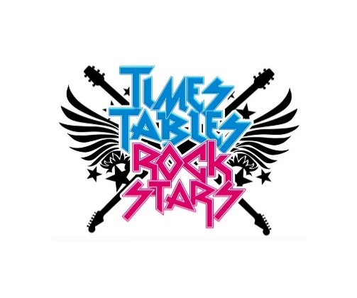We will be starting this term with a mystery...Who pushed Humpty Dumpty? This unit will focus on a whole new genre of writing for us! Some of our English work this term will be linked to Science, when we will write non-chronological reports about famous scientists and their discoveries.

# Maths Curriculum

This term we continue our big focus on multiplication and division, as well as introducing a new unit all about measuring length and perimeter. We will be practicing and testing times tables regularly, and will also be using times tables facts for problem solving and reasoning. All pupils have log-ins for Times Table Rockstars to practice our times table skills and we will be using this regularly in school. This is a great way to practice at home too!

# Topic

This term, we are focusing on Geography in our Topic lessons. We will be learning all about rivers and the Water Cycle! This will include discovering more about the rivers around the UK, improving our atlas skills and exploring how rivers change over time. To compliment this topic, trips to Bolton Abbey are scheduled for late January and early February. These excursions will have a strong Geography focus, giving pupils the opportunity to explore the meandering River Wharfe first-hand and participate in a workshop led by a qualified Forest School leader.

# Science

It’s going to be a loud one this term as we learn all about sound! We will be learning how our ears hear sounds, how sound is made on instruments and how sound travels. There are plenty of opportunities for hands on learning and experiments this term, we can’t wait to complete our scientific investigations!

# The Wider Curriculum

Year Four pupils are expected to complete their weekly homework on Google Classroom. Usernames and Passwords have previously been shared, but please contact the office/class teacher for reminders.



**Art** - our focus this term is to further develop our painting skills. We may get a bit messy in this unit! Texts will be sent to all classes about providing old shirts and cover-ups for painting.

**PSHE** - our PSHE focus this term is ‘what is important to me?’. We will be learning why people may eat or avoid certain foods (religious, moral, cultural or health reasons), learning more about other factors that contribute to people’s food choices (such as ethical farming, fair trade and seasonality) and learning about the importance of getting enough sleep.

**Computing** - Mr Bisiker will deliver Media and Technology to all pupils. Pupils will be using computers to design, create and manipulate digital content. Final edits of work will be shared via google classroom.

**Low Road and Windmill Music Federation**